DECLARATION OF CONFORMITY
Document Version: 1.0
Date of issue: 11/27/2024
Manufacturer details:
Copytech (UK) Ltd, Trading as Printondemand-worldwide.com
9 Culley Court
Orton Southgate
Peterborough
Cambridgeshire, PE2 6WA
United Kingdom
gpsr@podww.com
01733 237867
Product Type
- Product Type: Books
- List of products related to this document

Product Description
The products within this Product Type are books, used for reading made of paper.

Relevant Regulations and Standards
This Declaration of Conformity is issued under the sole responsibility of the manufacturer. The product complies with the requirements of the following EU regulation:
- General Product Safety Regulation (GPSR) 2023/988
- Classification, Labelling, and Packaging Regulation 1272/2008
- REACH Regulation 1907/2006

EU GPSR Authorised Representative
Appointed EU Representative: Easy Access System Europe Oü, 16879218
Address: Mustamäe tee 50, 10621, Tallinn, Estonia
Contact Details: gpsr.requests@easproject.com, +358 40 500 3575

Testing Information
The products have been tested for compliance with the relevant safety standards, including:
- REACH Regulation 1907/2006

Declaration Statement
We, Copytech (UK) Ltd, Trading as Printondemand-worldwide.com, declare under our sole responsibility that the products specified above conform to the safety and performance requirements of the EU General Product Safety Regulation (EU) 2023/988 and all other applicable directives and standards

Signature
In:
On Nov 27, 2024

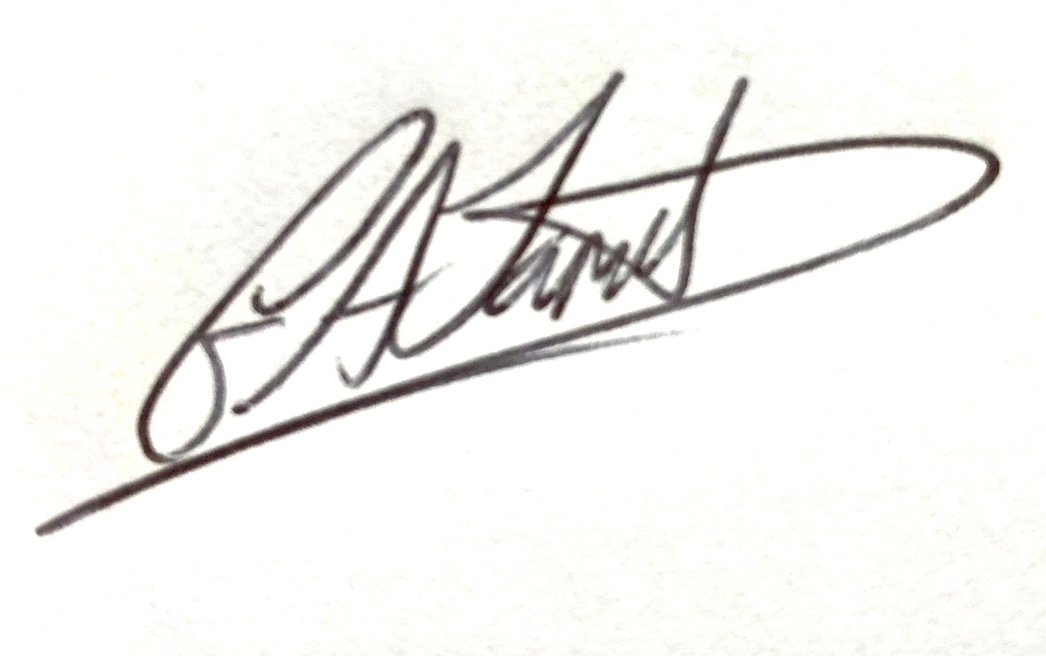

Name and Title: Gareth Jarrett, Head of Global Development

